(Approx. 1,655 words)

DVD Insider – DRM
Sometimes the Bad Guys Win for All the Wrong Reasons
By Andy Marken, Marken Communications
www.markencom.com
andy(at)markencom.com

Obtained from APCUG with the author's permission for publication by APCUG member groups.
“On the one hand information wants to be expensive, because it’s valuable. The right information in the right place just changes your life. On the other hand, information wants to be free, because the cost of getting it out is getting lower and lower all the time. So you have these two fighting each other.” -- Steward Brand, 1st Hackers’ Conference, 1984

Hollywood loves sequels.

They love proving they know what the consumer/viewer wants.

But they really had to reach when they heard some Doom9er yahoos had not only hacked their precious AACS DRM (Digital Rights Management) code.

The audacity!

Nothing to do but reach into the archives and take a page from one of the immortals…Mack Sennett.

Yep…nothing to do but call in the Keystone Cops…that’ll teach them.

Had they hacked it, passed it around amongst themselves the industry wouldn’t consider a change.

But what good is it to hack something that is hack-proof if no one knows about it?

They had to share their bragging rights.

And they did with postings at Diggs, on t-shirts and everywhere they could find the opportunity to expose themselves.



Figure 1 - Calling All Cops – The minute the AACS lawyers got the word that their DRM had been not only cracked but posted, they sprang into efficient action…they sued everyone! Source – Keystone Studios Archives
You know that wasn’t going to sit well with Tellywood’s guardians !

Take It Down Dude
They sent in their best armed with cease & desist letters to anyone, everyone who posted the elegant 32 digit code.

Great…another riot on the Web !

We need to note that creative people need to be paid for their work…writers, artists, animators, actors, makeup artists, best boys, post production folks, underwriters and yes even studio execs.

No pay…no play !

The problem is the world doesn’t want content protection.

Consumers don’t want content protection.

Hell…they aren’t too happy people are buying each other off to keep two blue formats alive!

All they want to do is watch the content when they want…where they want…how they want.

AACS had a better idea.

You want a copy to watch on your TV…buy it.

Want a copy to take to your cabin…buy it.

Want a copy to shut the kids while you drive to visit gramma…buy it.

Want a copy in the family room and bedroom…buy it.

Tellywood knew a gentler, kinder security solution wasn’t the answer.

Tried that with CSS (Content Scrambling System).

Sucker was busted before the ink was dry!

Slow Acceptance of New

So what if DVD took off like a rocket!

The technology shot past every PC/CE technology in consumer sales…ever.

Even with multiple formats, people snapped up players and burners.

Discs flew onto the shelves and out the doors like crazy.

And a huge underground pirate industry grew…trust us, these guys know pirates!

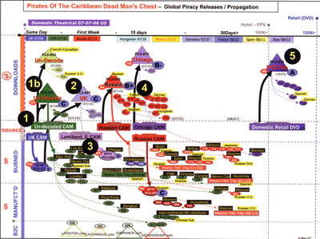
Figure 2 - The Fine Art of Pirate Tracking – Hollywood has spared no time or expense in tracking their loss of content. They know precisely how quickly ripped off copies will be in the hands of the buying public. True most of it comes from India and China but still there are those pesky hackers who have to learn a lesson…the hard way! Source – Walt Disney
HighDef was their opportunity to get back in control.

The new DRM was impressive…

Ok so maybe industry officials – music, theater – knew it was a bad idea but still…

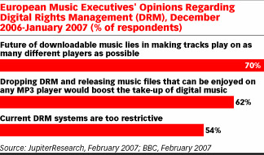

Figure 3 - Yeah But – The music and motion picture industries speak in whispers about the fact that DRM isn’t working. Problem is they haven’t figured out a way to simplify the process, procedure and still ensure they are properly compensated. That’s still a work in progress. Source – JupiterResearch, BBC

Ok so the real pirates weren’t worried after all they go to the source to get their content…keep their mouths shut…keep a low profile…make money.

Doom 9ers?

They have no lives.

They want bragging rights.

The fact that the 32-character sequence is useless is of no consequence.

After all you need to write a complete program around it to start copying HD movie discs. The key only unlocks movies made before April.

So who benefits?

Aaahhh… AACS lawyers.

Oh yeah and the bragging rights folks.

Download Practicality

They could also post the movies on the Web instead of making us rip our own copies but...

A 2-hour HD DVD download over DSL takes about 3 days.

Cable 18-19 hours.

Fiber about 2.5 hours.

Maybe that’s why video downloads are still “a work in progress”

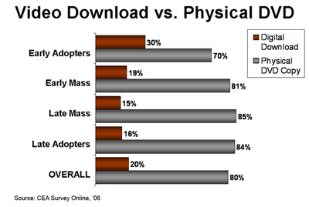
Figure 4 - Consumer Preference – While digital downloads of movies gets a lot of attention as the solution for entertainment of tomorrow, consumers just haven’t bought into the idea yet…even early adopters. It will probably be one of the viable options in a couple of years but until then people still want their discs. Source – CEA

Will it happen?

Sure.

But most consumers don’t want the hassle.

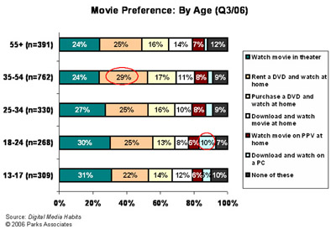
Figure 5 - Entertain Me – The entertainment options are out there but regardless of age more than 50% of consumers will either go to the theater or pick up a disc to watch at home. Downloads? All in due time. Source – Parks Associates

All folks want to do is watch their real world escape movies...or their educational shows…or their documentaries.

They don’t want to jump around these beautiful new discs to watch all the outtakes…director’s comments…interactive games…online updates!

They want to … watch the movie !!!

People don’t really want to be technology troubleshooters on top of their regular job…even if their regular job is IT.

So what was so great about the Doom9ers efforts and the AACS Keystone Cops response?

The kids showed the industry – content creators, hardware/software folks – that the money-making AACS DRM was little better than CSS.

Fortunately the blue technology hasn’t taken off like the proverbial rocket ship so the industry can make a course correction without ticking off millions of folks who laid out big bucks for their players and movie libraries.

Won’t as long as there are super-cheap DVD players and a gazillion of decent quality movies on DVD to buy…rent…rip !
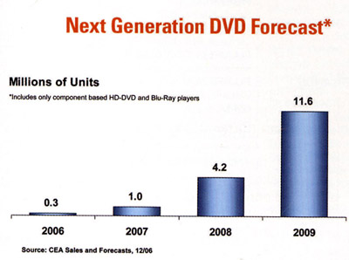
Figure 6 - Thanks Doom9ers – While hackers show their prowess by cracking the new AACS DRM, consumers are still content to watch their movies on current DVDs. Despite the hype and noise, it will take years for HD DVD and BD to become the viewing solution of choice. Source – CEA

Better Solutions

One of the best – and most expensive – solutions is watermarking (see Wikipedia).

When you buy or rent the content it is coded to you.

If it finds it’s way “into the channels”…busted!

There are a lot of technical and cost issues involved so it will probably never emerge from the lab.

Shades of Valenti
Since the DVD CCA (Copy Control Assn) lost in court they figured what the H*** they’ll do what governments’ do…legislate !

Cute little amendment for “their” license would say your stuff – movie or game – wouldn’t work unless there was a disc in the system…sheess !!!

We were so certain Jack Valenti had been put to rest. We now believe in unholy spirits…exorcism anyone?

The best solution and the one Sennett and his people should ultimately agree is good is Mandatory Managed Copy.

Don’t get your undies in a bunch…it only sounds restrictive.

With Managed Copy you buy the disc and watch it.

Want to play it on your TV top player…done.

Send it around the house to watch everywhere…done.

Need a copy to take with you in the car to shut the kids up or to take with you on your business flight…done.

There is even a formula for secure copy electronic distribution when the pipes beef up or you become a lot more patient.

Gee…it works for the consumer…and the content folks !

Consumers Aren’t Evil

Of course the AACS will say that all of those devious consumers are going to knock-off copies and give them to their friends…neighbors…family members…

Some might.

But my gawd most folks never made a copy of their VHS tapes or DVDs.

You may like them but take the time, trouble, expense to rip 2-3 copies?

Nope!

Oh sure Doom9ers and a few acne-infected kids might to make a few bucks.

But have you looked at the cost of the burners?

The media?

Expensive at least for another year!

Doom9ers will still say it’s restrictive. Remember…consumer content wants to be free!

But they don’t care a monkey’s armpit about the consumer.

Or the content owner.

All they want to do is brag about something…anything!

Consumers?

All they want to do is buy, rent their movies and watch them where they want…how they want…when they want.

Doom9 Benefit

By muddying the waters with their hacking expertise before a gazillion HighDef players and discs were in the market, Doom9ers made Tellywood and the PC/CE industry rethink their solution.

Managed Copy suddenly looks very appealing.

A helluva lot more appealing than having to carry your one disc with you everywhere!

If and when the gentler, kinder solution is implemented, will the AACS lawyers still have a job?

They can turn on the pirates who quietly follow content producers who make the big bucks selling bootleg discs on the sidewalks, street corners and thru the mail.

They can tighten up their internal security and make it more difficult to get to the content.



Figure 7 - Protecting The Flight – By developing an efficient, effective and consumer-friendly DRM solution, Hollywood will be able to turn their attention to more important things like keeping pirates from boarding early.

This article has been provided to APCUG by the author solely for publication by APCUG member groups. All other uses require the permission of the author (see e-mail address above).

